Sortıng algorıthms
analysıs report
05/05/2019

Prepared by
Alperen Bayraktar 150116501
Emre Erdem 150115501

TABLE OF CONTENTS
Prepared by 1
Table Of Contents 2
1 ALGORITHMS 4
  - Insertion Sort 4
  - Mergesort 4
  - Quick Sort
  - Heap Sort 4
  - Counting Sort 5
2 GENERAL ANALYSIS 6
2.1 Code 6
2.2 Graphs 6
2.3 Comments 6
3 CONCLUSION 8

ALGORITHMS

In this section, we analyzed different sorting algorithms one by one and we also compared it to the known theoretical complexity results such as big -Oh and others depending on different input sizes.

We gather input values randomly with a function as described below in the General Analysis topic.
 | Cases | Insertion | Merge | Quick | Heap | Counting
C(n) | Worst | n(n-1)/2 | n*log₂n-n+1 | (n+1)(n+2)/2 - 3 | 2(n- log₂n^{(n+1)}+ n*log₂n) | 2n + k
C(n) | Average | n²/4 |  | 2ln^{n} or 1.39n*log₂n |  | 2n + k
C(n) | Best | n-1 |  | n* log₂n |  | 2n + k
T(n) | Worst  (O(n)) | n² | n*logn | n² | n*logn | n + k
T(n) | Average  (Θ (n)) | n² | n*logn | n*logn | n*logn | n + k
T(n) | Best  (ꭥ(n)) | n | n*logn | n*logn | n*logn | n + k

Insertıon sort
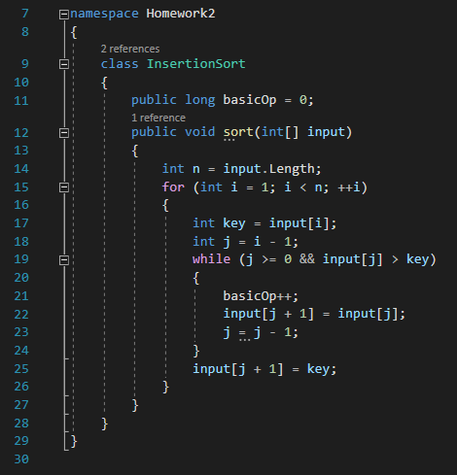

Insertion sort is one of the basic and elementary sorting algorithm. It is not considered as fast or better in terms of time complexity. Yet it is sometimes used for its properties such as when low overhead is needed. It is mostly used for nearly sorted inputs and also low input sized datas. Because it is also stable it is used as a recursive base case and it can adapt new inputs without dirtying the page or memory layout. Insertion sort is also doesn’t waste memory space while trying to sort numbers so it might be preffered for low memory devices.

In this algorithm we get worst case when the list is reversed. So insertion sort needs to go through all elements which results in O(n²) time complexity.

We choose comparisons as basic operation and increment it everytime a comparison occurs to find the total number of basic operations.

mergesort

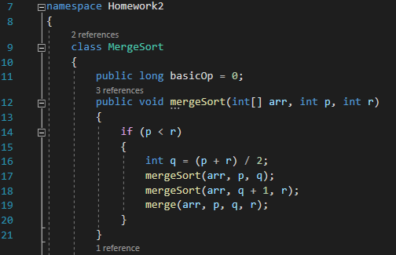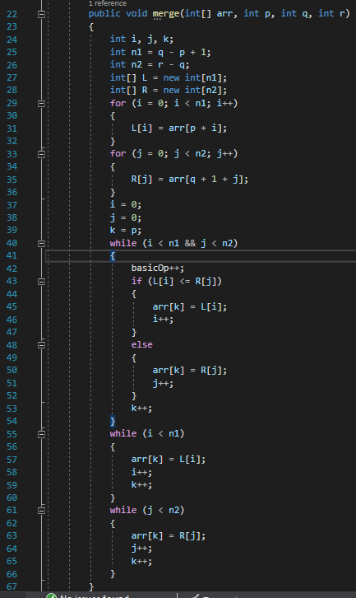

Merge sort is a divide and conquer algorithm to sort. Easy to implement in most situations. It is one of the fastest algorithms for sorting out there. It makes 0.5log(n)-log(n) comparison per value, also log(n) – 1.5log(n) swaps per value. It costs O(n) space complexity but for people who have that flexibility it is the only O(n.log(n)) that is stable algorithm. Also when using linked list it has theta-(log(n)) extra needed space for recursion. It’s also chosen when random access is more expensive than sequential access. Another negative for merge sort is also not as adaptive as insertion sort when new elements are presented to the algorithm.

Merge sort has time complexity of O(nlogn) for best, average, worst cases. It has different C(n) values that represent true outcome for these cases. We discuss them below.

We take comparison as our basic operation in this algorithm since it is the slowest operation and also the most repetitive one in the program. It divides the array to half recursively to single elements and it then compares these elements. That’s where we increment our basicOp value to reach our desired value.

quıck sort

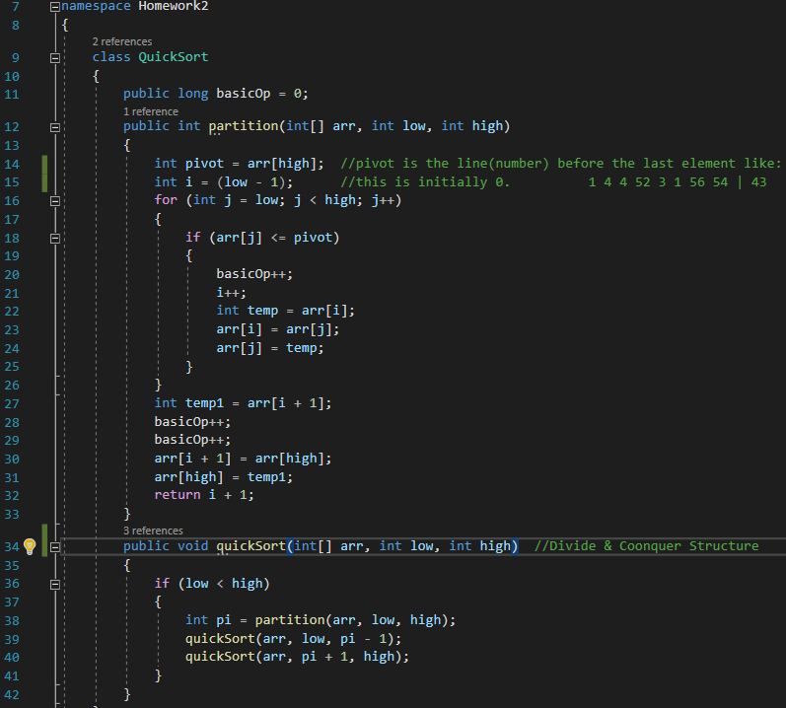

Quick sort has many different implementation mostly depending on pivot selections. 3-way pivot selection is considered to be one of the best. Yet we did not implemented that and implemented a conventional quick sort in our project to analyse.

Quick sort is considered to be robust and also has low overhead when carefully implemented. If stability is not a concern, quick sort is all around very good for general purpose sorting. Although 3-way partitioning method to be used when possible.

Even though worst case time complexity is O(n²) –more than merge sort and heap sort-, quick sort is faster when used, because it’s inner loop is efficiently implemented on most architectures also in most real world data. With different partition implementation like 3-way partition, worst case very rarely occurs for quick sort. However when the data is hugely large and stored in an external storage, merge sort is considered to be better generally.

Worst case for quick sort would be, partition taking largest and smallest valued elements picked as pivot element. In our example, worst case occurs when array is sorted already sorted in reverse or increasing order since the largest and smallest elemets will always be taken as pivots.

heap sort

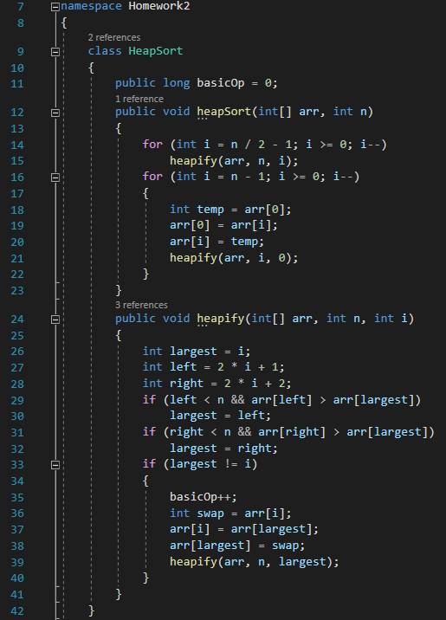

Heap sort is a simple to implement, O(nlogn) (relatively fast) algorithm to use. Unfortunely it’s not a stable algorithm so when used should be considered according to that.

In the first for loop we heapify the array. Meaning puts the array in heap order. In the second loop, it extracts maximum and renews the heap order. Both loop phases are slightly adaptive although in a useful manner.

When inputs are nearly sorted, heapify phase disregards that original order. In few unique keys case heap sort speeds up things but not as much as 3 way quicksort. In reversed ordered arrays, heapify phase is at its fastest since array is in heap order.

Heap has time complexities nlogn for best, worst and average cases.

We choose swap operation as our basic operation because heapify function is called everytime and swapping takes the most amount of time to compute.

COUNTINGSORT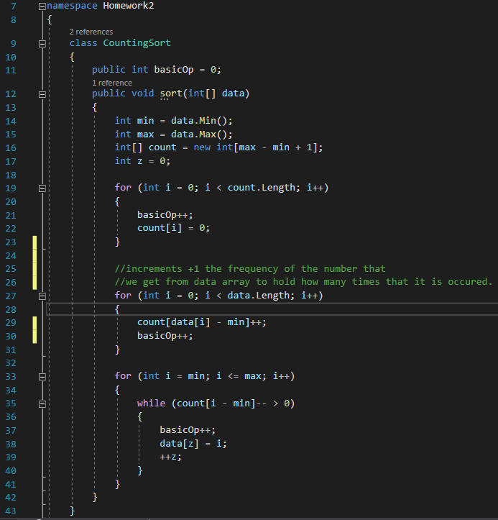

Counting sort is one of the fastest algorithm we have seen and tested for this projects input values. It’s time complexity and space complexity depends on difference between minimum and maximum value that any element can get (which is ‘k’ value). Also it has some problems with negative values that needs small twist to code to implement.

Counting sort is really efficient when input value range is not significantly greater than the number of elements to be sorted. That’s why for this project counting sort is the best algorithm timewise. It becomes linear as O(n+k). One of its setbacks is the space complexity as ‘k’ goes larger and larger. When implementing arrays that can have large ranges this may be problematic.
We took incremented basicOp for assignments both for n and also k, which affects even if it’ impact is very little compared.

GENERAL ANALYSIS

In this project we used variety of programs to reach our conclusions. We used C# programming language to implement our algorithms and write the outputs (such as time(ms) and basicOp count) to the according text files. We generate our input arrays randomly with the function described below according to the input size.

We used 150 different inputs for every input sizes and our input size range is 1000 to 100000 incrementing by 1000. This means 100 different input sizes are test for 150 times. 100*150 = 150,000 different input arrays with different sizes (1000 to 100,000) are tested for each algorithm to get accurate representation for every case.

We were also very carefull to test the same input composition for every different algorithm to get accurate results to compare. This means same input would be tested for all algorithms then it proceeds to the next input size/batch.

cODE

Test

GRAPHS

Test

COMMENTS

Test

CONCLUSION

referrences:

https://www.geeksforgeeks.org

https://www.tutorialspoint.com/

https://www.toptal.com/developers/sorting-algorithms/

https://brilliant.org/wiki/sorting-algorithms/

Introduction To Design Analysis Of Algorithms 3rd Edition Anany Levitin

